## **BANNER SELF-SERVICE WAITLIST INSTRUCTIONS FOR STUDENTS**

1. Open Banner Self-Service

***Login to the my Campus portal (http://mycampus.astate.edu) and click on the SSB icon Access***

* 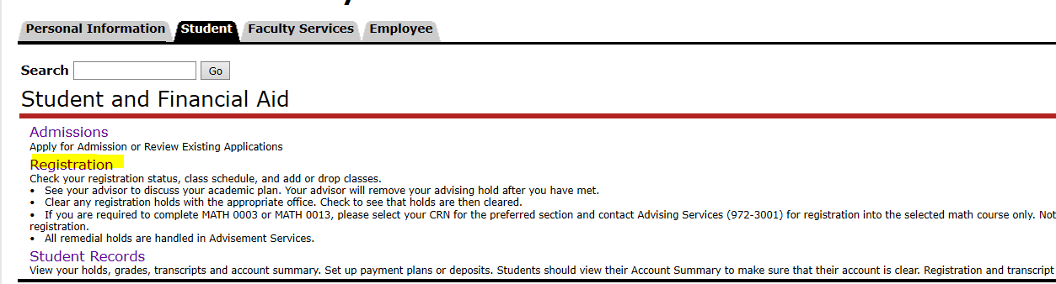

1. ***Add or Drop Classes***

***Select the term that you want to register for.***

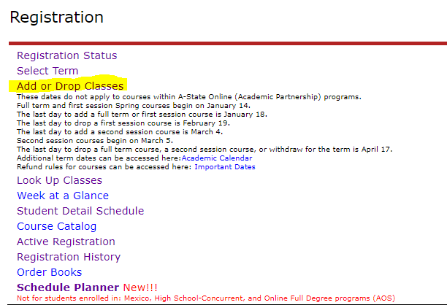

* *If you already know the CRN, click Add/Drop Classes, type the CRN in the box and click submit changes.*
* *If you do not know the CRN, use the Look-up Classes to Add. Search for your course(s) with waitlisting and write down the CRN. Click Add to Worksheet, type in CRN and click submit changes.*

1. ***aDD THE CLASS TO YOUR REGISTRATION LIST, iF THE CLASS HAS REACHED THE MAXIMUM ENROLLMENT CAPACITY, THEN IT WILL PROMPT YOU TO ADD THE CLASS AS WAITLIST CLASS.***

***click the waitlist option and SUBMIT CHANGES***

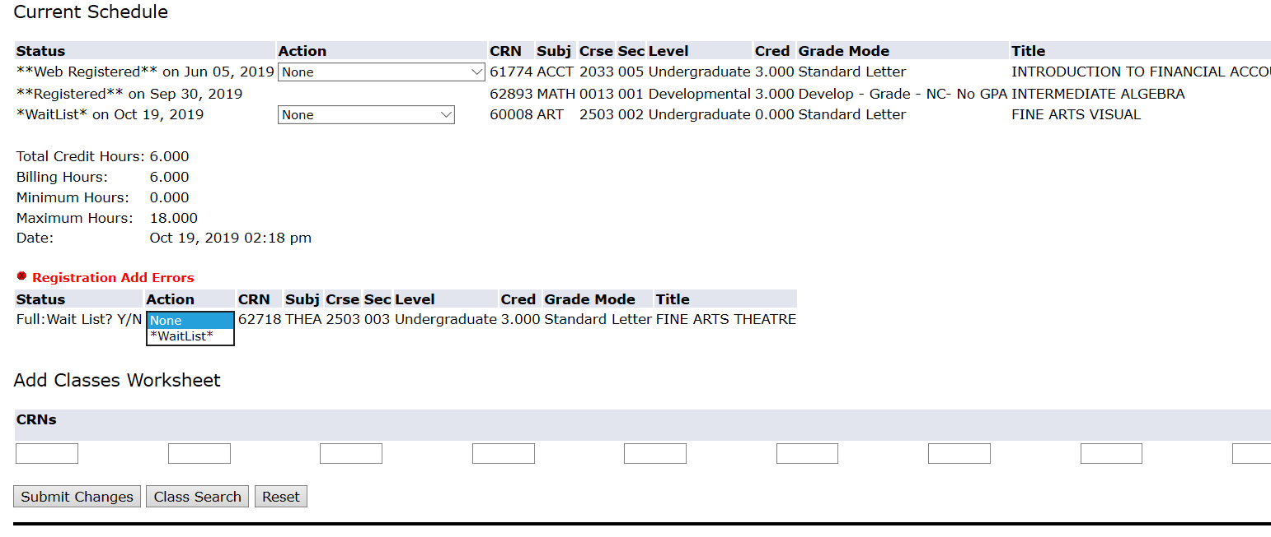

1. ***the current schedule page will have the waitlisted class in the list***

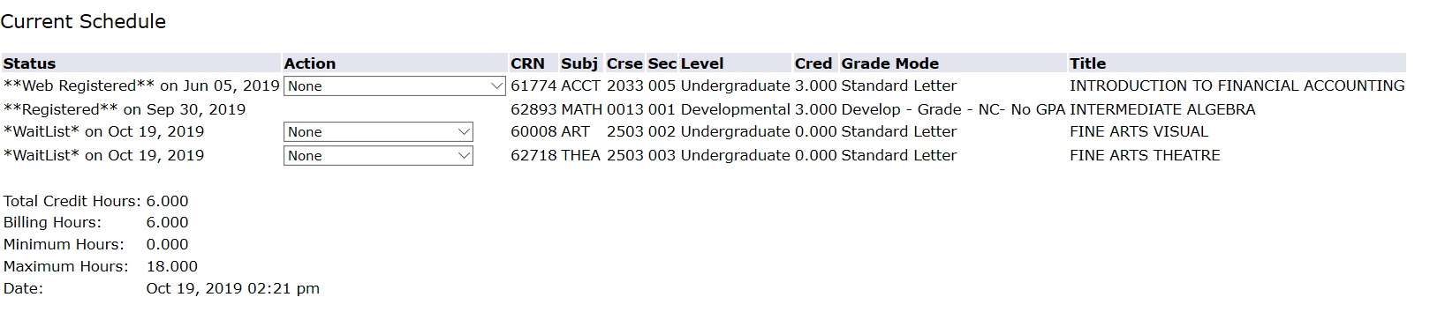

1. ***if the seat opens up IN the class then , you will get a notification in your ASTATE student email, stating you have 72 hours to register for the class***

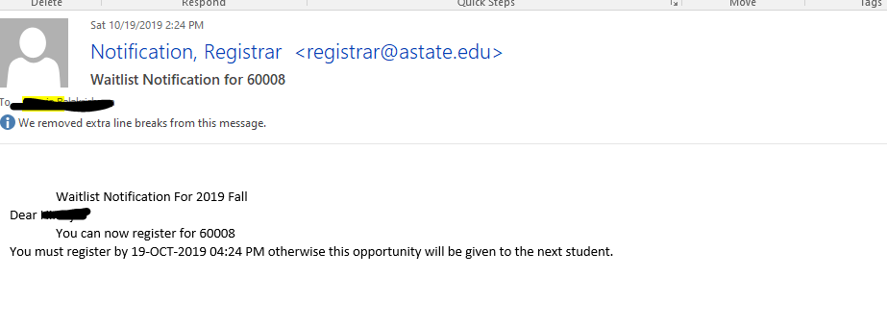

1. ***Another reminder Notification will be sent before 24 hours to your Astate student email account.***

**Please note: If you do not register within the timeframe, then the seat will be offered to the next student on the waitlist.**

1. ***After you receive notification, and would like to register for the waitlisted class, then click the drop down menu and add the class and submit your changes.***

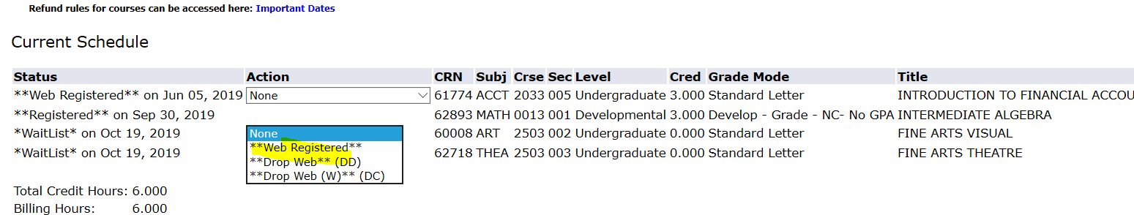

**Please contact you department Advisor in case you need any clarifications regarding the process**

***You can also visit:*** [***http://www.astate.edu/a/registrar/***](http://www.astate.edu/a/registrar/) ***to know more about the process***